LOG IN AND HASHING

NEW DAY THING

BUTTON PIVTURE IMPROVING THE GUI

READING FROM THE DATABASE

GRAPH

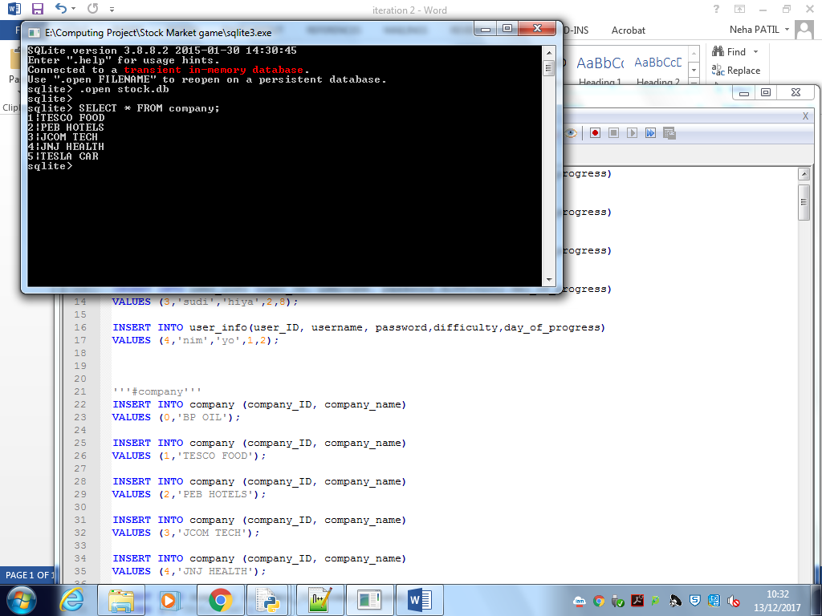

No record with primary key 0

Filled the record woth blank data will fix this in future iterations